1. Agenda:
   1. In this lecture, we will introduce deserialization problem in our Email Notification MS.
2. 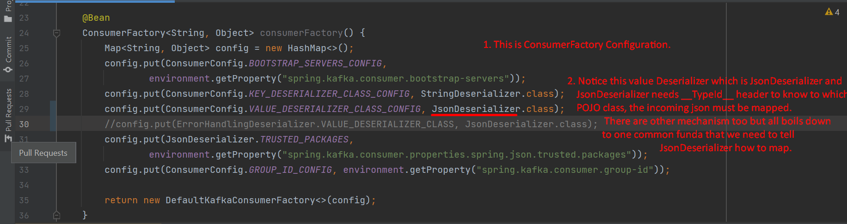
3. 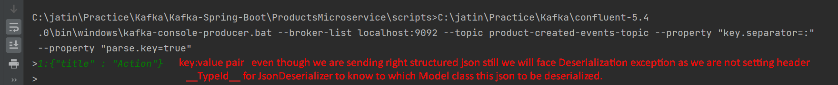
4. 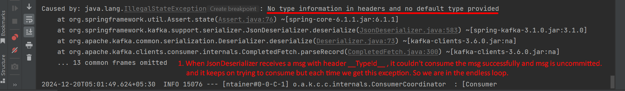
5. **NOTE**: Jatin -> Retry is performed only after msg marshalling is done successfully and exception occurs later on.